Chinese Green Beans

* [Nutrition](http://www.teambeachbody.com/teambeachbodyblog/category/nutrition)

* [Recipes](http://www.teambeachbody.com/teambeachbodyblog/category/nutrition/recipes)

February 16, 2015

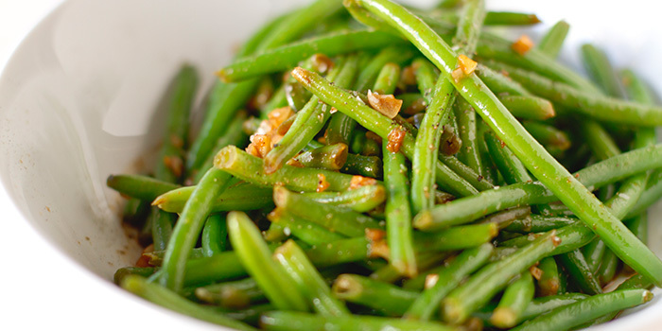

With a touch of soy sauce and ginger, these Chinese-inspired green beans make a delicious side.

**Total Time:** 17 min.  
**Prep Time:** 5 min.  
**Cooking Time:** 12 min.  
**Yield:** 4 servings

**Ingredients:**  
1 Tbsp. coconut oil  
3 cloves garlic, finely chopped  
1 lb. green beans (or Chinese long beans), edges trimmed  
4 green onions, chopped  
1-inch piece fresh ginger, peeled, finely chopped  
2 Tbsp. reduced-sodium soy sauce  
1 tsp. pure maple syrup (or raw honey)

**Preparation:**  
1. Heat oil in wok (or medium nonstick skillet) on medium-high heat.  
2. Add garlic, green beans and green onions; cook for 4 to 6 minutes.  
3. Add ginger, soy sauce, and maple syrup; cook, stirring frequently, for 2 minutes, or until green beans are tender-crisp. Do not overcook, or beans will become mushy.

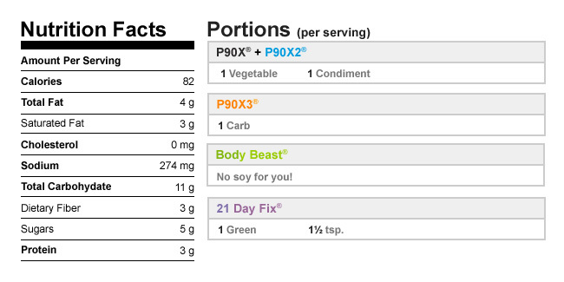

Authors

[Beachbody](http://www.teambeachbody.com/teambeachbodyblog/author/beachbody)

Tags[dinners](http://www.teambeachbody.com/teambeachbodyblog/tag/dinners), [lunches](http://www.teambeachbody.com/teambeachbodyblog/tag/lunches), [recipes](http://www.teambeachbody.com/teambeachbodyblog/tag/recipe),[vegan](http://www.teambeachbody.com/teambeachbodyblog/tag/vegan), [vegetables](http://www.teambeachbody.com/teambeachbodyblog/tag/vegetables),[vegetarian](http://www.teambeachbody.com/teambeachbodyblog/tag/vegetarian)

RELATED POSTS